EXPERIMENT - 3
E-Commerce Mobile App using the Figma Tool
Field | Details
Name | M.Ramprasadh
Register No. | 192511355
Course Code | CSA1007
Date | 26 October 2026
Tool Used | Figma (design and interactive prototype); Visual Studio Code

1. Aim

2.Objectives
- Understand the difference between a sketch, a wireframe and a prototype.
- Plan the screens and the user flow of an e-commerce shopping app before designing.
- Create mobile frames in Figma and design three screens with a consistent colour palette, text styles and components.
- Link the screens with prototype interactions so that the shopping flow can be clicked through.
- Present the prototype, publish or share it, and capture screenshots of every screen.
- Build the app as an HTML/CSS/JavaScript page, run it on localhost and compare it with the Figma design.

3. Basic Concepts (in Simple Words)
Figma: A web-based design tool used to design the look of apps and websites and to link the screens into a clickable demo. It needs no installation and works in the browser.
Prototype: A simple, early model of an app. It looks and behaves like the real app (buttons can be clicked) but it has no real database or payment system behind it.
Frame: A container in Figma that acts like one phone screen. Each screen of the app is one frame.
Component: A reusable design element, such as a product card or a button, that is drawn once and used many times.
Auto layout: A Figma feature that arranges the items inside a frame (spacing, padding, direction) automatically.
Interaction (Prototype link): A rule such as "when the user clicks a product card, open the Product detail screen".
User flow: The path a user follows to finish a task. Here: Home > Product detail > Shopping bag.
E-commerce: Buying and selling of goods online. A shopping app lets the user browse products, save favourites, add items to a bag and check out.

4. Requirements
- A computer with an internet connection and a web browser (Google Chrome was used for Figma and Microsoft Edge for the local page).
- A free Figma account (sign in at figma.com).
- Visual Studio Code and Python installed, for running the local HTML version.
- The project files: index.html, README.txt and start.bat (folder RAMPRASADH_Ecommerce_Localhost).
- Assumption: one home page with six sample products in four categories (Shoes, Audio, Tech, Style) is enough for the prototype. All prices, ratings and product photos are sample data.

5. Design Plan

5.1 Screens and user flow
No. | Screen | Purpose | Main element
1 | Home | Search the catalogue, filter by category and browse products | Search bar, category chips and product grid
2 | Product detail | See the large photo, rating, description and price of one product | Product image, colour swatches and Add to bag button
3 | Shopping bag | Review the selected items and the total | Item row with Remove, total and Checkout button

Flow: Home > Product detail > Shopping bag > Home (close). A product can also be saved with the heart button on the Home and Product detail screens.

5.2 Design choices
Item | Value | Used for
Paper (background) | #FBFAF7 | Screen background and bottom bars
Ink (text colour) | #211F1C | Headings and body text
Muted grey | #8B8882 | Small labels, categories and sub-text
Accent orange | #D85C3F | View all link, Remove link, saved heart and category label on the detail screen
Dark button | #242321 | Active category chip, Add to bag and Checkout buttons
Line | #EEEAE4 | Thin dividers above the bottom bars
Frame size | iPhone frame (about 393 x 852) | All three screens
Font | Sans-serif (Inter / system) | Titles medium-bold, labels small and grey

6. Step-by-Step Procedure

Part A: Set Up Figma and the Frames
- Open Figma. Open a browser, go to figma.com and sign in with your account. Click Create new (or the + button) and choose Design file to open a blank canvas.
- Name the file. Double-click the file title at the top and rename it E-Commerce App Prototype.
- Create the first frame. Press F (Frame tool). In the right panel choose Phone > iPhone so that a mobile-sized frame appears. Rename it 1 Home (double-click the name in the Layers panel).
- Duplicate the frame. Select the frame and press Ctrl + D twice. Rename the copies 2 Product detail and 3 Shopping bag and place the three frames side by side.
- Save the colour styles. Select a shape, click the fill colour, and use the + in Styles to save #FBFAF7 (Paper), #211F1C (Ink), #8B8882 (Muted), #D85C3F (Accent) and #242321 (Dark button). Using styles keeps all screens consistent.

Part B: Design Screen 1 - Home
- Draw the header. Inside frame 1 add the small label CURATED FOR YOU and the brand name RAMPRASADH. in bold on the left, and a round light-grey icon button on the right.
- Add the search bar. Draw a white rounded rectangle with a thin border and add a search icon and the placeholder text Search the edit.
- Create the hero banner. Place a rounded photo of clothes on a rail, add a dark gradient on the left side, and type the small label THE NEW ESSENTIALS, the heading Objects worth living with. and an underlined link Shop the edit ↗ in white.
- Add the Discover section. Add the heading Discover with the orange View all link, the grey sub-text "Thoughtful pieces, selected daily" and a row of category chips: All (dark, selected), Shoes, Audio, Tech and Style.
- Build one product card. Draw a rounded product photo with a white round heart button at the top right. Below it add the grey category label (SHOES), the product name (Mono Runner), the price ($128) and the rating (★ 4.9). Select the items and press Shift + A to apply Auto layout.
- Turn the card into a component. Press Ctrl + Alt + K to create a component. Place three more instances in a two-column grid and change only the photo and text: Studio One (AUDIO, $179, 4.8), Field Camera (TECH, $249, 4.7) and Everyday Tote (STYLE, $89, 4.8).
- Add the bottom navigation. At the bottom draw a bar with four items: Home, Explore, Saved and Profile, each with an icon and a label. Colour the active tab (Home) dark. The finished screen is shown in Figure 1.
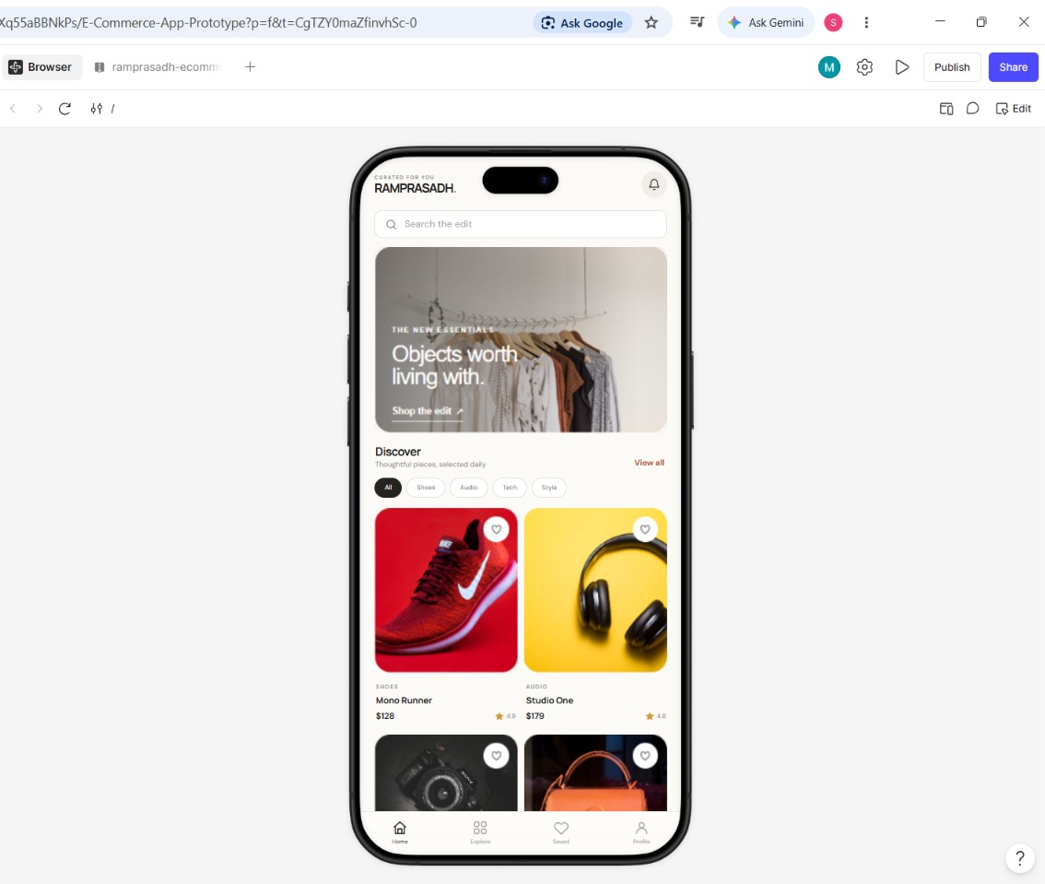
Figure 1: Screen 1 - Home screen of the RAMPRASADH prototype in Figma

Part C: Design Screen 2 - Product Detail
- Add the product image. In frame 2 place a large photo (headphones) filling the top part of the screen. Add a round white back button at the top left and a round white heart button at the top right.
- Add the product information. Below the image add the orange label AUDIO, the rating ★ 4.8 · 124 reviews, the title Studio One and a short grey description of the product.
- Add the colour choice. Add the label Color followed by three round swatches: black (selected), sand and terracotta.
- Add the bottom bar. At the bottom draw a white bar showing the small label Price with $179 on the left and a dark rounded Add to bag button with a bag icon on the right (Figure 2).
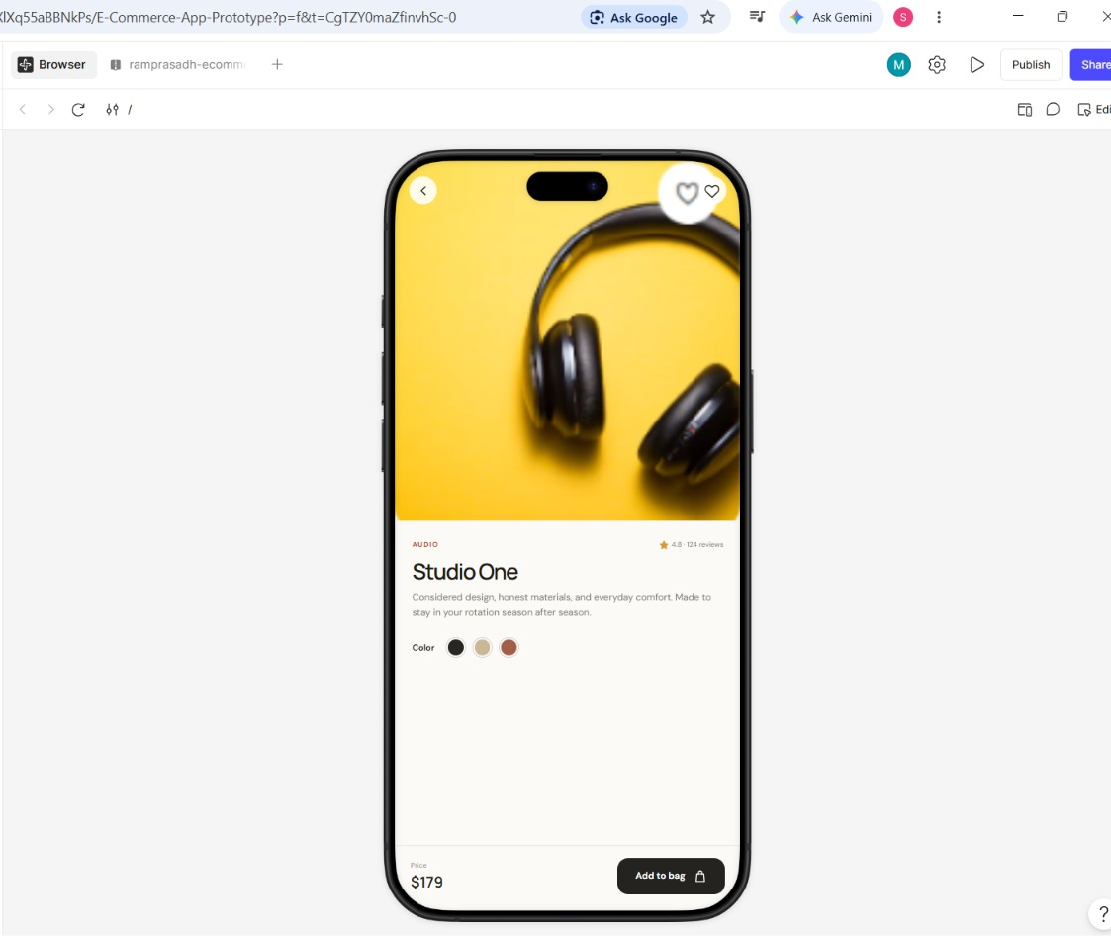
Figure 2: Screen 2 - Product detail screen (Studio One, $179)

Part D: Design Screen 3 - Shopping Bag
- Add the title bar. In frame 3 add the small label YOUR SELECTION, the heading Shopping bag and a round close (×) button on the right.
- Add the item row. Add a thumbnail of the selected product (Mono Runner), its category label (SHOES), its name, the price ($128) and an orange Remove link on the right, with a thin divider below.
- Add the total bar. At the bottom draw a white bar with the label Total and $128 on the left and a dark Checkout button on the right (Figure 3).
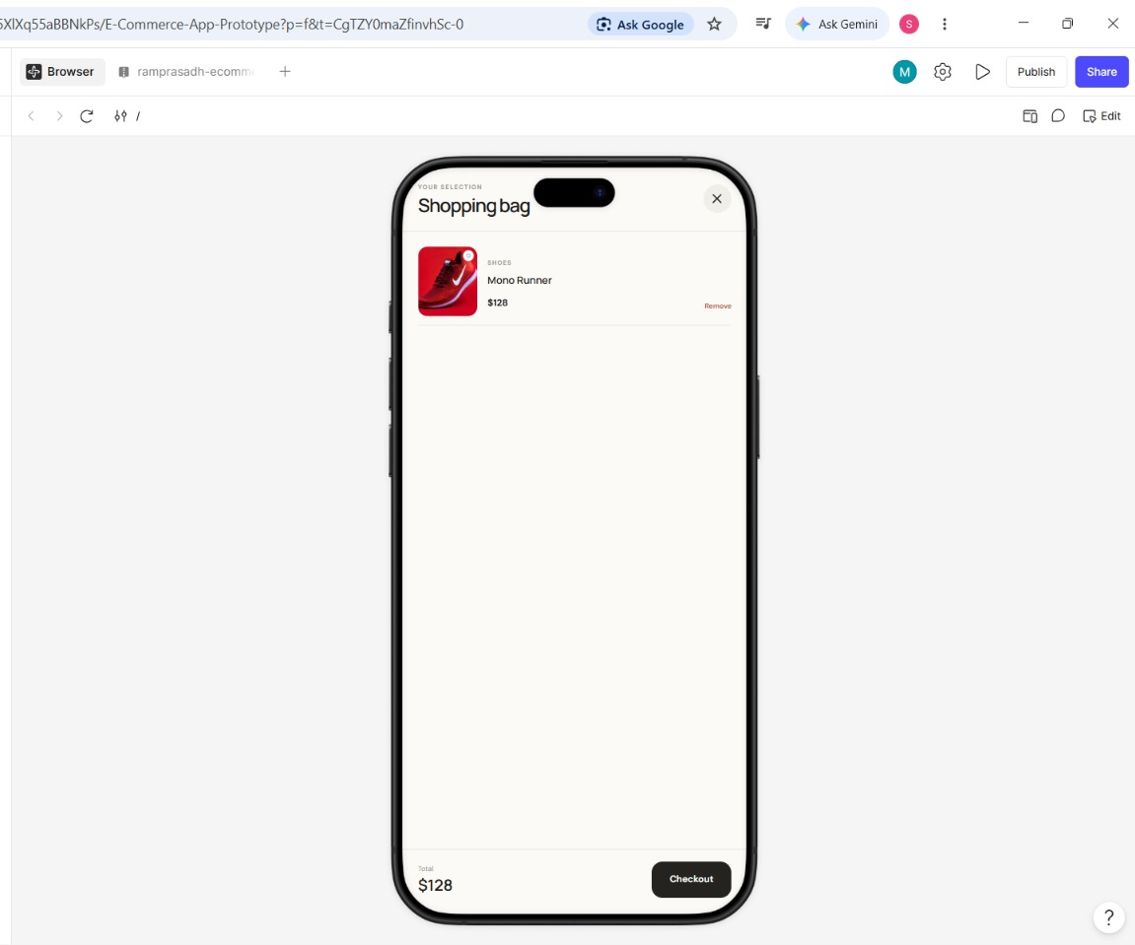
Figure 3: Screen 3 - Shopping bag with one item and the total

Part E: Link the Screens (Prototype)
- Open the Prototype tab. In the right panel click Prototype. Select an element and drag the small circle that appears on its edge to the target frame.
- Create the links. For each link set Trigger = On click, Action = Navigate to and Animation = Smart animate (or Move in), using Table 1.

Element | Trigger | Action | Destination
Product card or photo (Screen 1) | On click | Navigate to | 2 Product detail
Add to bag button (Screen 2) | On click | Navigate to | 3 Shopping bag
Back button (Screen 2) | On click | Navigate back | Previous screen
Close (×) button (Screen 3) | On click | Navigate to | 1 Home
Table 1: Prototype interactions used in the RAMPRASADH flow
- Set the starting frame. Select frame 1 Home and mark it as the Starting point (flow start) in the Prototype panel.
- Test the prototype. Click the Play (▶) button at the top right. Click a product, press Add to bag, check the Shopping bag screen and press close to return to Home. Correct any wrong link.
- Publish and share. Click Publish or Share at the top right to get a link for the prototype, and set the access (view only) as required.

Part F: Build the App as a Local Web Page (VS Code)
To confirm that the design can be turned into working code, the whole app (Home, Product detail, Saved, Bag and Profile) was also built as one HTML file with CSS and JavaScript.
- Create the project folder. Create a folder RAMPRASADH_Ecommerce_Localhost and open it in Visual Studio Code (File > Open Folder).
- Add the files. Create index.html (all the HTML, CSS and JavaScript), README.txt and start.bat. In index.html the colours from the Figma design are stored as CSS variables, for example --paper: #fbfaf7 and --accent: #d85c3f (Figure 4). The full code is given in Section 10.
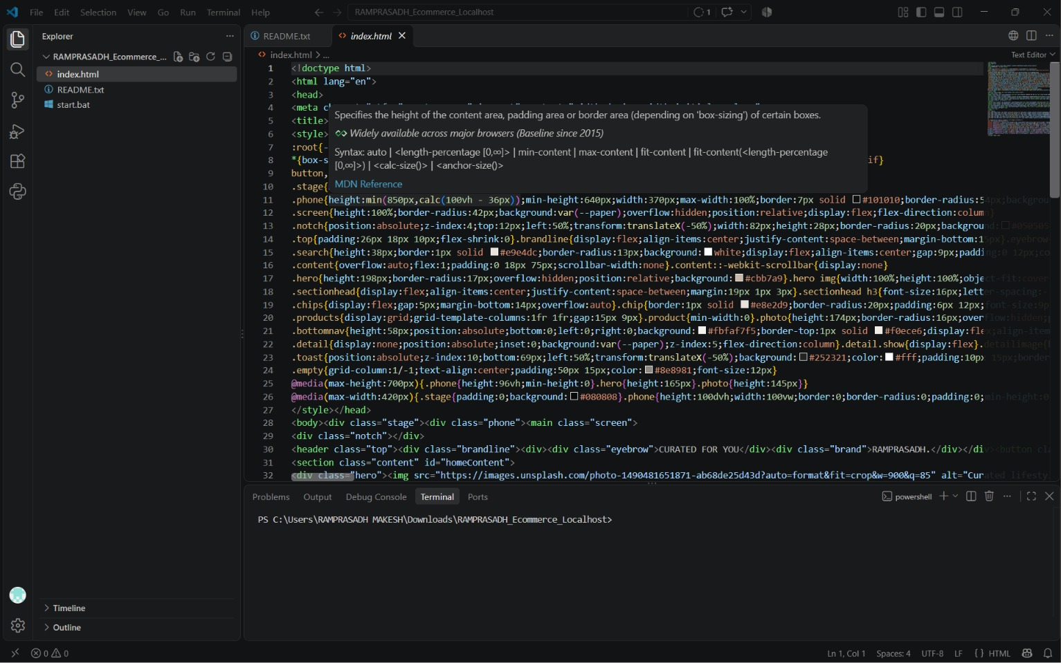
Figure 4: index.html in Visual Studio Code - project files in the Explorer and colour variables defined at the top of the style section
- Start the local server. Open the Terminal in VS Code and run the command below. (The start.bat file in the same folder is the Windows shortcut for starting the page.)
python -m http.server 8001
- Preview the page. Open http://127.0.0.1:8001/ in the VS Code Simple Browser or in Microsoft Edge. The RAMPRASADH home screen appears inside a phone frame (Figures 5 and 6).
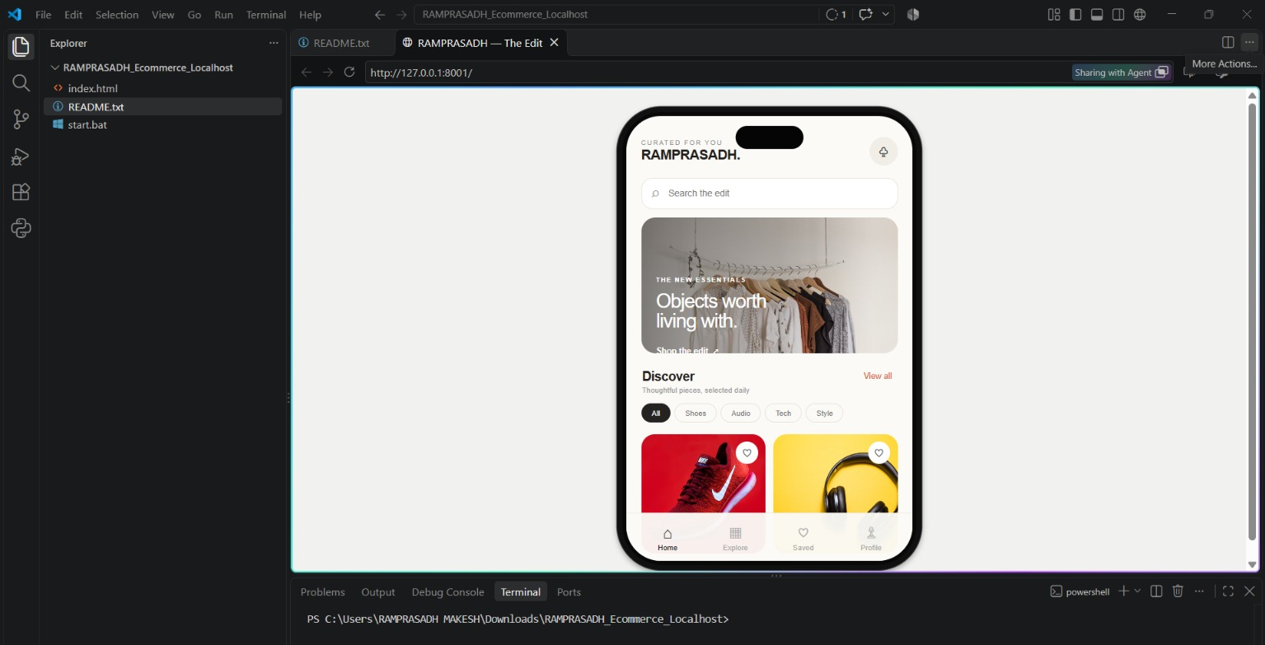
Figure 5: RAMPRASADH page running at http://127.0.0.1:8001/ inside the VS Code preview, with the project files in the Explorer
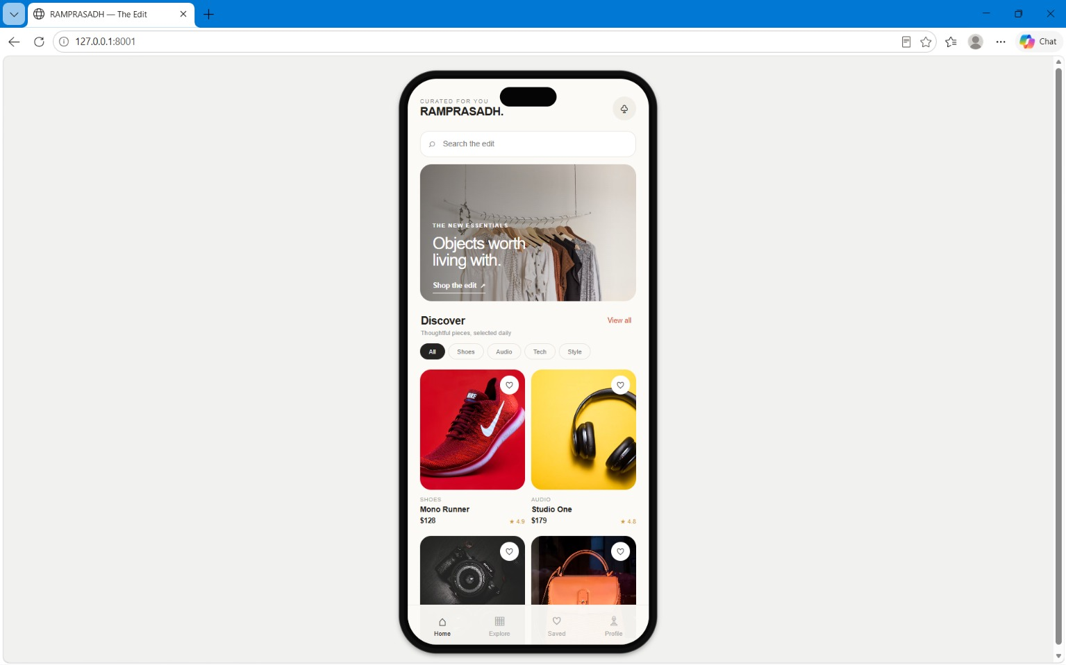
Figure 6: RAMPRASADH home screen opened in the Microsoft Edge browser at 127.0.0.1:8001
- Test the features. Click a category chip (Shoes, Audio, Tech, Style) to filter the products and type in the search box to find a piece by name. Tap the heart to save a piece (the count appears on the Saved tab), click a product to open its detail screen, choose a colour, press Add to bag, open the bag icon to see the total, press Remove to delete an item and press Continue to checkout to see the demo message.

Part G: Capture the Output
- Take screenshots. Capture each Figma screen in the Play mode (Figures 1 to 3) and the VS Code and browser views (Figures 4 to 6), and paste them under the matching step in this record.

7. Observation
Sample product data used in the prototype
No. | Product | Category | Price | Rating | Screen
1 | Mono Runner | Shoes | $128 | 4.9 | Home, Bag
2 | Studio One | Audio | $179 | 4.8 | Home, Detail
3 | Field Camera | Tech | $249 | 4.7 | Home
4 | Everyday Tote | Style | $89 | 4.8 | Home
5 | Air Buds | Audio | $99 | 4.6 | Local page
6 | Everyday Watch | Tech | $219 | 4.9 | Local page

Results of the flow test
No. | Action | Expected result | Status
1 | Click a product card on Home | Product detail screen opens | Pass
2 | Click Add to bag | Shopping bag screen opens with the item and total | Pass
3 | Click the close (×) button | Returns to the Home screen | Pass
4 | Click a category chip (local page) | Only products of that category are shown | Pass
5 | Type in the search box (local page) | Products are filtered by name | Pass
6 | Tap the heart (local page) | Heart turns orange; Saved tab shows the count | Pass
7 | Add to bag, then Remove (local page) | Bag total updates; item is removed | Pass

The prototype has 3 screens and 4 clickable links, and the complete shopping journey can be followed in the Play mode. Reusing the product card component kept the screens consistent and saved time. The local HTML page reproduces the Home screen closely and adds working behaviour (category filter, search, saved pieces, colour choice and a bag with a running total), but it uses sample data only and checkout shows a demo message because no payment is processed. Small differences were noted between the two versions: the header icon is a bell in the Figma design and a bag symbol on the local page, and the bag is a full screen in Figma but a tab inside the phone frame on the local page.

8. Result
A simple, clickable prototype of the e-commerce app RAMPRASADH – The Edit was sketched in Figma with three linked screens: Home, Product detail and Shopping bag. The app was also implemented as a local web page and run successfully at http://127.0.0.1:8001/ using Visual Studio Code and Python.

9. Conclusion
This experiment showed how Figma can be used to plan and test an app idea before any real programming is done. Frames, a fixed colour palette, reusable components and simple On-click links were enough to build a complete shopping flow that can be presented and shared. Running the app as HTML, CSS and JavaScript on localhost showed how the same design can later be developed into a working application, with a real product database, user accounts and payment added in the next stages.

10. Source Code
The complete source code of the local page is given below. The project folder RAMPRASADH_Ecommerce_Localhost contains index.html (HTML, CSS and JavaScript), README.txt and start.bat. Run it with the command python -m http.server 8001 and open http://127.0.0.1:8001/.

10.1 index.html
<!doctype html>
<html lang="en">
<head>
<meta charset="utf-8"><meta name="viewport" content="width=device-width,initial-scale=1">
<title>RAMPRASADH — The Edit</title>
<style>

:root{--paper:#fbfaf7;--ink:#211f1c;--muted:#8b8882;--accent:#d85c3f;--line:#eeeae4}
*{box-sizing:border-box}
body{margin:0;background:#f1f1ef;color:var(--ink);font-family:Inter,Arial,sans-serif}
button,input{font:inherit}
button{cursor:pointer}
.stage{min-height:100vh;display:flex;align-items:center;justify-content:center;padding:22px}
.phone{height:min(850px,calc(100vh - 36px));min-height:640px;width:370px;max-width:100%;border:7px solid #101010;border-radius:54px;background:#080808;padding:5px;box-shadow:0 3px 7px #0006,0 0 0 1px #555;position:relative}
.screen{height:100%;border-radius:42px;background:var(--paper);overflow:hidden;position:relative;display:flex;flex-direction:column}
.notch{position:absolute;z-index:4;top:12px;left:50%;transform:translateX(-50%);width:82px;height:28px;border-radius:20px;background:#050505}
.top{padding:26px 18px 10px;flex-shrink:0}
.brandline{display:flex;align-items:center;justify-content:space-between;margin-bottom:15px}
.eyebrow{font-size:8px;letter-spacing:1.5px;color:#888}
.brand{font-size:17px;font-weight:650;letter-spacing:-.7px;margin-top:1px}
.round{border:0;background:#f1eee8;border-radius:50%;width:34px;height:34px;display:grid;place-items:center;color:#242321;font-size:17px}
.search{height:38px;border:1px solid #e9e4dc;border-radius:13px;background:white;display:flex;align-items:center;gap:9px;padding:0 12px;color:#999}
.search input{border:0;outline:0;width:100%;font-size:11px;background:transparent;color:#333}
.content{overflow:auto;flex:1;padding:0 18px 75px;scrollbar-width:none}
.content::-webkit-scrollbar{display:none}
.hero{height:198px;border-radius:17px;overflow:hidden;position:relative;background:#cbb7a9}
.hero img{width:100%;height:100%;object-fit:cover}
.hero:after{content:"";position:absolute;inset:0;background:linear-gradient(90deg,#1714118c,transparent 90%)}
.hero-copy{position:absolute;z-index:1;left:18px;top:39%;color:white}
.hero-copy small{font-size:8px;letter-spacing:1.1px;font-weight:700}
.hero-copy h2{font-size:24px;line-height:1.02;letter-spacing:-1px;font-weight:500;margin:7px 0 13px}
.hero-copy a{font-size:10px;font-weight:600;color:white;text-decoration:none;border-bottom:1px solid #fff;padding-bottom:5px}
.sectionhead{display:flex;align-items:center;justify-content:space-between;margin:19px 1px 3px}
.sectionhead h3{font-size:16px;letter-spacing:-.5px;margin:0;font-weight:650}
.sectionhead button{border:0;background:none;color:var(--accent);font-size:10px}
.sub{font-size:9px;color:#999;margin:3px 1px 11px}
.chips{display:flex;gap:5px;margin-bottom:14px;overflow:auto}
.chip{border:1px solid #e8e2d9;border-radius:20px;padding:6px 12px;font-size:9px;background:transparent;color:#777;white-space:nowrap}
.chip.active{background:#242321;color:white;border-color:#242321}
.products{display:grid;grid-template-columns:1fr 1fr;gap:15px 9px}
.product{min-width:0}
.photo{height:174px;border-radius:16px;overflow:hidden;position:relative;background:#eee}
.photo img{height:100%;width:100%;object-fit:cover;display:block;transition:transform .25s}
.product:hover .photo img{transform:scale(1.04)}
.heart{position:absolute;top:9px;right:9px;width:27px;height:27px;border-radius:50%;border:0;background:#fffF;color:#555;font-size:17px;display:grid;place-items:center}
.heart.saved{color:var(--accent)}
.category{font-size:8px;color:#a19b92;letter-spacing:.6px;margin-top:9px}
.pname{font-size:11px;margin-top:4px;font-weight:550}
.pfoot{display:flex;justify-content:space-between;align-items:center;font-size:10px;margin-top:5px}
.price{font-weight:600}
.rating{color:#d79b34;font-size:9px}
.bottomnav{height:58px;position:absolute;bottom:0;left:0;right:0;background:#fbfaf7f5;border-top:1px solid #f0ece6;display:flex;align-items:center;justify-content:space-around;padding:5px 9px 3px;z-index:3}
.navitem{border:0;background:none;color:#aaa;font-size:9px;display:flex;flex-direction:column;align-items:center;gap:3px;min-width:48px}
.navitem .ico{font-size:19px;line-height:20px}
.navitem.active{color:#252321}
.count{font-size:8px;background:var(--accent);color:white;border-radius:8px;padding:1px 4px;position:absolute;margin-left:13px;margin-top:-4px}
.detail{display:none;position:absolute;inset:0;background:var(--paper);z-index:5;flex-direction:column}
.detail.show{display:flex}
.detailimage{height:46%;position:relative;flex-shrink:0;background:#eee}
.detailimage img{width:100%;height:100%;object-fit:cover}
.detailimage .round{position:absolute;top:22px;left:15px;background:#ffffffde}
.detailimage .heart{top:22px;right:15px}
.detailscroll{padding:18px 18px 90px;overflow:auto;flex:1}
.meta{display:flex;justify-content:space-between;align-items:center;font-size:8px;color:#a5a099}
.meta .category{margin:0;color:var(--accent);font-size:8px;font-weight:700}
.detailtitle{font-size:22px;letter-spacing:-.8px;margin:10px 0 7px;font-weight:600}
.desc{font-size:10px;color:#89847d;line-height:1.6;margin:0 0 16px}
.colors{display:flex;align-items:center;gap:8px;font-size:9px}
.swatch{width:19px;height:19px;border:2px solid white;box-shadow:0 0 0 1px #ddd;border-radius:50%;padding:0}
.swatch.active{box-shadow:0 0 0 1.5px #262421}
.detailbottom{position:absolute;bottom:0;left:0;right:0;padding:13px 15px;background:#fbfaf7;border-top:1px solid #f0ece6;display:flex;align-items:center;justify-content:space-between}
.detailbottom small{display:block;font-size:8px;color:#aaa;margin-bottom:4px}
.detailbottom strong{font-size:16px;font-weight:600}
.add{background:#242321;color:white;border:0;border-radius:13px;padding:13px 18px;font-size:10px;font-weight:600;min-width:110px}
.toast{position:absolute;z-index:10;bottom:69px;left:50%;transform:translateX(-50%);background:#252321;color:#fff;padding:10px 15px;border-radius:20px;font-size:10px;white-space:nowrap;display:none}
.toast.show{display:block}
.empty{grid-column:1/-1;text-align:center;padding:50px 15px;color:#8e8981;font-size:12px}
@media(max-height:700px){.phone{height:96vh;min-height:0}
.hero{height:165px}
.photo{height:145px}}
@media(max-width:420px){.stage{padding:0;background:#080808}
.phone{height:100dvh;width:100vw;border:0;border-radius:0;padding:0;min-height:0;box-shadow:none}
.screen{border-radius:0}
.notch{top:10px}
.top{padding-top:25px}}

</style></head>
<body><div class="stage"><div class="phone"><main class="screen">
<div class="notch"></div>
<header class="top"><div class="brandline"><div><div class="eyebrow">CURATED FOR YOU</div><div class="brand">RAMPRASADH.</div></div><button class="round" id="bagTop" aria-label="Shopping bag">♧</button></div><label class="search"><span>⌕</span><input id="search" placeholder="Search the edit" autocomplete="off"></label></header>
<section class="content" id="homeContent">
<div class="hero"><img src="https://images.unsplash.com/photo-1490481651871-ab68de25d43d?auto=format&fit=crop&w=900&q=85" alt="Curated lifestyle objects"><div class="hero-copy"><small>THE NEW ESSENTIALS</small><h2>Objects worth<br>living with.</h2><a href="#discover" id="shopEdit">Shop the edit&nbsp; ↗</a></div></div>
<div class="sectionhead" id="discover"><h3>Discover</h3><button id="viewAll">View all</button></div><div class="sub">Thoughtful pieces, selected daily</div>
<div class="chips" id="chips"><button class="chip active" data-cat="All">All</button><button class="chip" data-cat="Shoes">Shoes</button><button class="chip" data-cat="Audio">Audio</button><button class="chip" data-cat="Tech">Tech</button><button class="chip" data-cat="Style">Style</button></div>
<div class="products" id="products"></div>
</section>
<section class="content" id="savedContent" style="display:none"><div class="sectionhead"><h3>Saved pieces</h3></div><div class="sub">Your considered favourites</div><div class="products" id="savedProducts"></div></section>
<section class="content" id="bagContent" style="display:none"><div class="sectionhead"><h3>Your bag</h3></div><div class="sub">Good choices, all in one place</div><div id="bagItems"></div></section>
<section class="content" id="profileContent" style="display:none"><div class="sectionhead"><h3>Your profile</h3></div><div class="sub">A little space for your edit.</div><p style="font-size:12px;line-height:1.7;color:#777">Welcome to RAMPRASADH. Your personal edit of thoughtful everyday essentials.</p><button class="chip" id="backDiscover">Back to discover</button></section>
<nav class="bottomnav"><button class="navitem active" data-tab="home"><span class="ico">⌂</span>Home</button><button class="navitem" data-tab="explore"><span class="ico">▦</span>Explore</button><button class="navitem" data-tab="saved"><span class="ico">♡</span><span>Saved <b id="savedCount" class="count" style="display:none">0</b></span></button><button class="navitem" data-tab="profile"><span class="ico">♙</span>Profile</button></nav>
<div class="detail" id="detail"><div class="detailimage"><img id="dimg" src="" alt=""><button class="round" id="closeDetail">‹</button><button class="heart" id="dheart">♡</button></div><div class="detailscroll"><div class="meta"><span class="category" id="dcat">TECH</span><span class="rating">★ <span id="drating">4.7</span> · 124 reviews</span></div><h2 class="detailtitle" id="dtitle">Field Camera</h2><p class="desc" id="ddesc">Considered design, honest materials, and everyday comfort. Made to stay in your rotation season after season.</p><div class="colors"><b>Color</b><button class="swatch active" style="background:#242321" aria-label="Black"></button><button class="swatch" style="background:#cbb99b" aria-label="Sand"></button><button class="swatch" style="background:#a76049" aria-label="Terracotta"></button></div></div><div class="detailbottom"><div><small>Price</small><strong id="dprice">$249</strong></div><button class="add" id="addBag">Add to bag&nbsp; ♧</button></div></div>
<div class="toast" id="toast"></div>
</main></div></div>
<script>

const items=[
{id:1,name:"Mono Runner",cat:"Shoes",price:128,rating:"4.9",img:"https://images.unsplash.com/photo-1542291026-7eec264c27ff?auto=format&fit=crop&w=700&q=85",desc:"Lightweight everyday sneakers with a clean silhouette and considered comfort."},
{id:2,name:"Studio One",cat:"Audio",price:179,rating:"4.8",img:"https://images.unsplash.com/photo-1505740420928-5e560c06d30e?auto=format&fit=crop&w=700&q=85",desc:"Beautifully balanced sound, tactile details, and a design made for daily listening."},
{id:3,name:"Field Camera",cat:"Tech",price:249,rating:"4.7",img:"https://images.unsplash.com/photo-1516035069371-29a1b244cc32?auto=format&fit=crop&w=900&q=85",desc:"Considered design, honest materials, and everyday comfort. Made to stay in your rotation season after season."},
{id:4,name:"Everyday Tote",cat:"Style",price:89,rating:"4.8",img:"https://images.unsplash.com/photo-1590874103328-eac38a683ce7?auto=format&fit=crop&w=700&q=85",desc:"An easy, versatile carryall crafted for all the small essentials of the day."},
{id:5,name:"Air Buds",cat:"Audio",price:99,rating:"4.6",img:"https://images.unsplash.com/photo-1606220945770-b5b6c2c55bf1?auto=format&fit=crop&w=700&q=85",desc:"Compact wireless audio with a simple, comfortable fit."},
{id:6,name:"Everyday Watch",cat:"Tech",price:219,rating:"4.9",img:"https://images.unsplash.com/photo-1523275335684-37898b6baf30?auto=format&fit=crop&w=700&q=85",desc:"A quietly confident timepiece for everyday wear."}
];
let category="All",query="",saved=new Set(),bag=[],current=null;
const $=s=>document.querySelector(s);
function card(p){return `<article class="product"><div class="photo"><img src="${p.img}" alt="${p.name}" loading="lazy" data-open="${p.id}"><button class="heart ${saved.has(p.id)?'saved':''}" data-heart="${p.id}" aria-label="Save ${p.name}">${saved.has(p.id)?'♥':'♡'}</button></div><div class="category">${p.cat.toUpperCase()}</div><div class="pname" data-open="${p.id}">${p.name}</div><div class="pfoot"><span class="price">$${p.price}</span><span class="rating">★ ${p.rating}</span></div></article>`}
function render(){let filtered=items.filter(p=>(category==="All"||p.cat===category)&&p.name.toLowerCase().includes(query.toLowerCase()));
$('#products').innerHTML=filtered.length?filtered.map(card).join(''):'<div class="empty">No pieces found. Try another search.</div>';
let sv=items.filter(p=>saved.has(p.id));
$('#savedProducts').innerHTML=sv.length?sv.map(card).join(''):'<div class="empty">Nothing saved yet.<br><br>Tap ♡ on a piece you love.</div>';
$('#savedCount').textContent=saved.size;
$('#savedCount').style.display=saved.size?'inline':'none';
$('#bagItems').innerHTML=bag.length?bag.map((p,i)=>`<div style="display:flex;gap:12px;padding:12px 0;border-bottom:1px solid #eee"><img src="${p.img}" style="width:68px;height:75px;object-fit:cover;border-radius:10px"><div style="flex:1;font-size:12px"><b>${p.name}</b><p style="color:#888;margin:7px 0">$${p.price}</p><button class="chip" data-remove="${i}">Remove</button></div></div>`).join('')+`<p style="font-weight:600;font-size:14px">Total&nbsp; $${bag.reduce((s,p)=>s+p.price,0)}</p><button class="add" id="checkout" style="width:100%">Continue to checkout</button>`:'<div class="empty">Your bag is feeling light.<br><br>Find something you love in Discover.</div>'; }
function toast(msg){$('#toast').textContent=msg;
$('#toast').classList.add('show');setTimeout(()=>$('#toast').classList.remove('show'),1800)}
function openDetail(id){current=items.find(p=>p.id===Number(id));if(!current)return;
$('#dimg').src=current.img;
$('#dtitle').textContent=current.name;
$('#dcat').textContent=current.cat.toUpperCase();
$('#dprice').textContent='$'+current.price;
$('#drating').textContent=current.rating;
$('#ddesc').textContent=current.desc;
$('#dheart').textContent=saved.has(current.id)?'♥':'♡';
$('#dheart').classList.toggle('saved',saved.has(current.id));
$('#detail').classList.add('show')}
function showTab(tab){$('#homeContent').style.display=(tab==='home'||tab==='explore')?'block':'none';
$('#savedContent').style.display=tab==='saved'?'block':'none';
$('#bagContent').style.display=tab==='bag'?'block':'none';
$('#profileContent').style.display=tab==='profile'?'block':'none';
document.querySelectorAll('.navitem').forEach(n=>n.classList.toggle('active',n.dataset.tab===tab||(tab==='explore'&&n.dataset.tab==='explore')));
$('#detail').classList.remove('show');}
function toggleSaved(id){id=Number(id);saved.has(id)?saved.delete(id):saved.add(id);
render();if(current&&current.id===id){$('#dheart').textContent=saved.has(id)?'♥':'♡';
$('#dheart').classList.toggle('saved',saved.has(id))}}
$('#chips').addEventListener('click',e=>{let b=e.target.closest('[data-cat]');if(!b)return;category=b.dataset.cat;
document.querySelectorAll('.chip[data-cat]').forEach(c=>c.classList.toggle('active',c===b));
render()});
document.addEventListener('click',e=>{let open=e.target.closest('[data-open]');if(open){openDetail(open.dataset.open);return}
let heart=e.target.closest('[data-heart]');if(heart){toggleSaved(heart.dataset.heart);return}
let rem=e.target.closest('[data-remove]');if(rem){bag.splice(Number(rem.dataset.remove),1);
render();toast('Removed from your bag')}});
$('#search').addEventListener('input',e=>{query=e.target.value;category='All';
document.querySelectorAll('.chip[data-cat]').forEach(c=>c.classList.toggle('active',c.dataset.cat==='All'));
render()});
document.querySelectorAll('.navitem').forEach(n=>n.addEventListener('click',()=>{if(n.dataset.tab==='explore'){showTab('home');
$('#search').focus();return}showTab(n.dataset.tab)}));
$('#bagTop').addEventListener('click',()=>showTab('bag'));
$('#closeDetail').addEventListener('click',()=>$('#detail').classList.remove('show'));
$('#dheart').addEventListener('click',()=>current&&toggleSaved(current.id));
$('#addBag').addEventListener('click',()=>{if(current){bag.push(current);
render();
$('#detail').classList.remove('show');toast(current.name+' added to your bag')}});
$('#viewAll').addEventListener('click',()=>{category='All';query='';
$('#search').value='';
render();
$('#homeContent').scrollTo({top:240,behavior:'smooth'})});
$('#shopEdit').addEventListener('click',()=>{setTimeout(()=>$('#homeContent').scrollTo({top:240,behavior:'smooth'}),0)});
$('#backDiscover').addEventListener('click',()=>showTab('home'));
document.querySelectorAll('.swatch').forEach(s=>s.addEventListener('click',()=>{document.querySelectorAll('.swatch').forEach(x=>x.classList.remove('active'));s.classList.add('active')}));
document.addEventListener('click',e=>{if(e.target.id==='checkout')toast('Checkout demo — no payment is processed')});
render();
</script></body></html>

